Student’s name | …………………………………………………….…… | Grade | 2
Subject | Computer | Week No. | 2
Lesson Title | Photo Gallery | Unit
Worksheet No. ( 2 ) (Answer)

Instruction: Match the following

 | Digital Camera
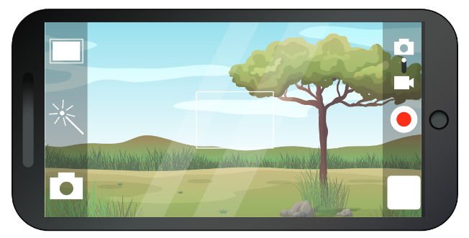 | Webcam
 | Smartphone

Good Luck

